
Job Description and Person Specification

Life Coach (Clinical Psychologist)

Department | Children’s Services
Service | Corporate Parenting Service
Grade | Scale M
Reports to | Assistant Director Children’s Social Care

Job Purpose
The Life Coach is a Clinical Psychologist working within the No Wrong Door Service. The term ‘Life Coach’ is used with the young people in the hope that it may reduce the stigma that can be attached to accessing CAMHS/ mental health support. Life Coaches are based at each NWD hub to provide open access to in-house psychological services.
The fact that this role is based at the NWD hub and is ‘embedded’ into the service, offers young people proactive, flexible and easy access to a Clinical Psychologist who can be understanding and persistent, reach out to the young person, work in settings that the young person is comfortable in, and be ready to adapt practice to suit the young person. The embedded presence of the Life Coach maximises the opportunity to build a trusting relationship through which intensive support can be provided and enables them to undertake:

Assessments:
• Formulations (psychological understanding based on theory/research):
• Interventions: σ in response to a difficulty or problem e.g. stress, anxiety, anger or any other emotional difficulty; σ where there is no identified difficulty or problem, but to contribute towards improving young people’s potential.

The Life Coach also work to continually ensure staff’s understanding of young people’s emotional needs and difficulties are continually improved. Staff have access to clinical supervision and training leading to highly effective work with young people, and their support includes:
• Training
• Consultation
• Supervision
• Day-to-day interactions.
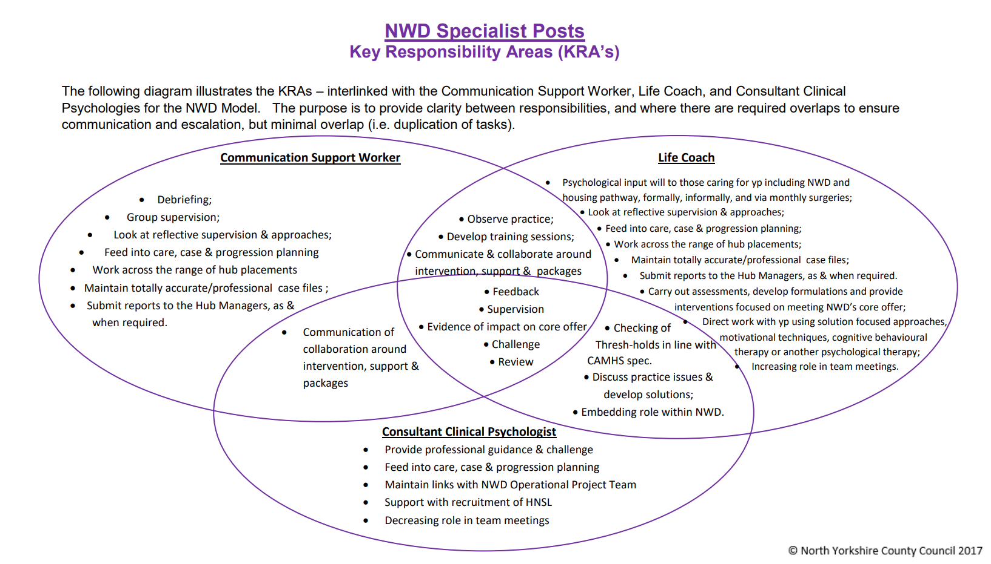
Overview/Context
Norfolk’s social care model is a relationship-based, purposeful approach with social workers practicing in a trauma informed way, incorporating therapeutic approaches within their work with children and young people, their carers and families.

Children’s Services practice vision ‘Vital Signs for Children’ is the way we
approach practice in Norfolk. We strive to work as a whole system and with
the whole family using a practice approach that is:

- Relationship based – working to build consistent and trusted relationships with families.
- Strengths oriented – identifying the strengths of families and building on them to create positive change.
- Outcome focused - doing whatever it takes to achieve the best outcome for children, young people and their families.

We believe it is vital that children are prepared and able to learn; build positive, long term relationships and receive family-based care. This role is within the No Wrong Door model which is a non-traditional approach to working with young people experiencing complex journeys. It combines short term residential care placements and edge of care support through a range of specialist and wrap-around services. The service aims to reduce the cycle of young people moving between multiple foster placements, or into residential care, reduced the numbers in high cost independent placements and reduced missing episodes, arrests, and hospital admissions as well as reducing the numbers coming into care.

Principal Accountabilities
You will provide highly specialist psychological assessment of clients with highly complex conditions based on the appropriate use, interpretation and integration of data from a variety of sources.
Responsible for recognising the potential for or signs of client harm, abuse or neglect, including poor clinical practice, reporting all such concerns and taking all reasonable steps to protect the client. Responsible for identifying and reporting concerns regarding the safeguarding of children who may be at risk.

Undertakes risk assessment and risk management for individual clients and provides specialist advice to other professionals on psychological aspects of risk assessment and risk management.

Formulates plans for highly specialist psychological therapy and/or management of clients’ mental health conditions based upon an appropriate conceptual framework and evidence-based practice.

Negotiates the implementation of such plans with clients and/or their carers.
Implements a range of highly specialist psychological therapies for individual clients, carers, families and groups, adjusting and refining psychological formulations as required.

Undertakes highly skilled evaluations and makes decisions about treatment options.

Provides highly specialist psychological advice, guidance and consultation to other staff contributing directly to client’s diagnosis, formulation and intervention plan.

Facilitates decision-making by planning and mapping processes/interventions with members of the team to determine the most appropriate treatment modality or service for clients.

Responsibility for Information Systems
Responsible for maintaining accurate and comprehensive patient/client records using Liquid Logic in accordance with the NCC record keeping standards.

Writes reports for other members of the multidisciplinary team and external parties regarding patient/client related matters

Uses psychometric testing software packages.

May use software packages for statistical analysis.

May be required to undertake administrative tasks in relation to own work
Uses Microsoft Office applications on a daily basis.

Responsibility for Planning/Organising & Strategic/Business Development
Organises own workload on a day to day basis, prioritising work as appropriate.

Plans individual patient/client care and acts as care co-ordinator/lead practitioner, where appropriate, ensuring the provision of a multidisciplinary care package appropriate for the client’s needs. Monitors progress during the course of multidisciplinary interventions.

You will continue to develop skills in the area of professional post-graduate teaching, training, consultation and supervision and maintain, through active participation in internal and external CPD training and development programmes, in consultation with the postholder’s line manager.
Other Job Information
An enhanced Disclosure and Barring Service check will be undertaken every three years.

Staff will need to be mentally and physically fit for the purpose of the work that they are to perform

All staff will have their performance and fitness to carry out their role formally appraised at least once annually in relation to Regulation 13.5 of the ‘Guide to Children’s Homes Regulations’ and will have regular supervisions with their line manager to discuss any issue they may have.

It is also important to be aware that you will be working with complex and emotionally difficult cases. You may be required to visit family homes where conditions and hygiene may be poor/unsafe, and you may encounter drug/alcohol abusing service users. You may also encounter extreme behaviours and possibly violence from the young people you are caring for.

This role may on occasions require some flexible working to be fully responsive to the support needs of young people at times that are convenient to them. This work should normally fall within the provisions of NCC flexible working policies.

You are required to travel as part of your duties, working in a range of settings and to undertake home visits, visits to Children’s Homes and foster placements, some will be outside of Norfolk. You will be responsible for your own travel arrangements and these must be carried out in the most effective and efficient way to perform your job.

Person Specification
Qualifications
Essential | Desirable
Signs of Safety Training or willingness to undertake within the first year of appointment.  Postgraduate Doctorate in Clinical Psychology (or its equivalent for those trained prior to 1996) and Registration with HCPC. | Further specific training or qualification relevant to working with and in support of young people.
Knowledge/Experience
Essential | Desirable
Experience working as a qualified clinician and relevant experience for transition to experienced clinical psychologist.  Previous experience of working in CAMHS or experience in Adult Services with clear evidence of transferrable skills.  Experience of specialist assessments and devising treatment for children or adults with behaviours that challenge.  Experience of group-work.  Experience of working with a wide range of mental health problems.  Experience of care planning.  Experience of working in a multidisciplinary way.  Experience in crisis work.  Experience of supervising others.  Knowledge of contextual safeguarding and other safeguarding factors for children and young people  Understanding of human growth and development, including transition, change and loss.  Awareness of current national guidelines and policies in the field of CAMHS.  Knowledge of legislation and its implication for clinical practice in relation to children, young people and their families (e.g. Children Act, Leaving Care Act, youth justice, housing). | Specific experience of working with Looked After Children, Care Experienced young people.  Experience working with complex PTSD  Training in diagnostic assessments (i.e. ADOS-2 and/or 3DI).  Experience in delivering interventions in patients’ homes.  Experience of working in a culturally diverse area or working with Asylum Seekers of any age.
Aptitudes/Behaviors (All Essential)
Evidence of well-developed clinical skills.

Specialist clinical skills for the assessment and treatment of complex trauma with comorbid challenging behaviours.

Skilled in emergency and crisis assessments.

Able to manage own time to prioritise work.

Skills in supervising others.
Excellent verbal and written communication skills with the ability to maintain accurate electronic recording

Demonstrable skills in communicating with young people, their parents and family members, other adults and professionals – the ‘parenting network’

Relationship building skills - including ability to relate to young people, their families, and other adults relevant to them.

Ability to support children and young people to raise their aspirations, whilst also supporting and challenging the team around that child/young person to hold aspirational practice.

Ability to work in a therapeutic and restorative way, utilising evidence-based models to effect change within individuals and systems

Ability to analyse situations and data and produce concise, sensitive and accurate assessments and reports.

Ability to set and maintain appropriate boundaries and accept responsibilities as a professional adult while still demonstrating respect and consideration for individual young people.

Ability to work within NCC’s framework for confidentiality and data protection.

Ability to identify and assess factors contributing to adolescent and young adult mental health and emotional well-being and developing appropriate interventions for these.

Evidence of ability to lead, support and influence others.

Teaching skills, both in clinical setting and education centres.

Ability to deal sensitively with stressful situations including staff and /or organisational problems, child abuse, family breakdown, serious mental ill health, and to cope with verbal abuse and to recognise and diffuse potential physical abuse from clients.

Ability to work autonomously, setting appropriate goals, in accordance with professional ethics guidelines and Norfolk County Council policies.

Computer skills, including Excel.

Capacity to constructively engage young people and families with different ethnic/cultural backgrounds.

Appointment will be subject to a satisfactory enhanced disclosure and barring service check to assess the suitability of candidates to work with children or other vulnerable groups.

The Council’s values and strengths
- Take accountability (Do what we say we will)
- Make strategy happen (Take action which makes Norfolk a better place)
- Be evidence based (Target our work to make the biggest difference)
- Be business-like (Think smarter to ensure value for money)
- Be collaborative (Work together to find a better way)

General Information
The job description details the main outcomes of the job and will be updated if these outcomes change.

All work performed/duties undertaken must be carried out in accordance with relevant County Council and Departmental policies and procedures, within legislation, and with regard to the needs of our customers and the diverse community we serve.

Job holders will be expected to understand what is meant by safeguarding vulnerable groups (children, young people and adults) and how to raise concerns.

Job holders will be expected to be flexible in their duties and carry out any other duties commensurate with the grade and falling within the general scope of the job, as requested by management.

Rewards and Benefits at Norfolk County Council

We offer a range of benefits working for Norfolk County Council, visit our Rewards and Benefits page to find out more.

To view further information visit our Recruitment information for candidates pages.

